Phase 2 Lab Report: Network Segmentation with pfSense (LAN + DMZ)
Environment: VirtualBox | Kali (LAN client) + Ubuntu (DMZ server) + pfSense (router/firewall)
Date: 20 Dec 2025

1. Objectives
- Build a segmented network and prove the security policy using command-line evidence.
- LAN → DMZ: allow only TCP 22 (SSH) and TCP 8000 (HTTP lab).
- LAN → DMZ: block all other ports (example: TCP 21).
- DMZ → LAN: block all initiated traffic.

2. Topology
Logical topology and addressing are shown in Figure 1.

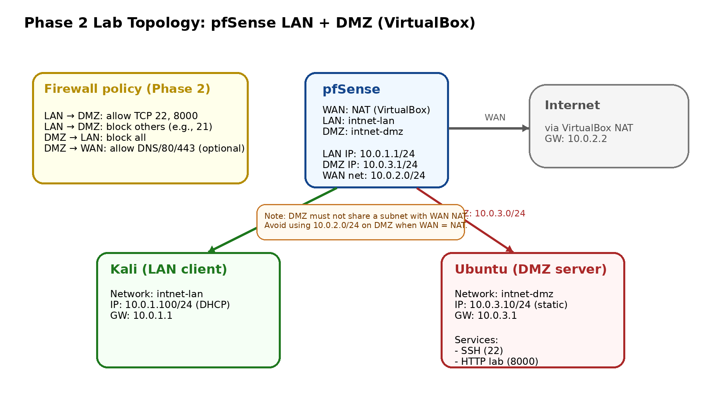
Figure 1. Phase 2 topology (pfSense with LAN and DMZ networks).

3. Key Configuration Summary
Node | Network | IP / Mask | Gateway
pfSense (LAN) | intnet-lan | 10.0.1.1/24 | —
pfSense (DMZ/OPT1) | intnet-dmz | 10.0.3.1/24 | —
pfSense (WAN) | NAT | 10.0.2.0/24 (GW 10.0.2.2) | DHCP
Kali | LAN | 10.0.1.100/24 (DHCP) | 10.0.1.1
Ubuntu | DMZ | 10.0.3.10/24 (static) | 10.0.3.1

4. Issue Encountered and Fix
- Problem: The DMZ was initially configured as 10.0.2.0/24 while the pfSense WAN (VirtualBox NAT) also used 10.0.2.0/24. This placed two pfSense interfaces in the same IPv4 subnet, causing routing ambiguity and broken connectivity.
- Fix: Change DMZ to a different subnet (10.0.3.0/24). After the change, Ubuntu could reach the DMZ gateway (10.0.3.1) successfully.

5. Firewall Policy Implementation
- Create an alias for the DMZ server (optional but recommended):
- Firewall → Aliases → IP: DMZ_UBUNTU = 10.0.3.10
- LAN rules (Firewall → Rules → LAN):
- Pass TCP 22 from LAN net → 10.0.3.10
- Pass TCP 8000 from LAN net → 10.0.3.10
- Block any from LAN net → 10.0.3.0/24 (placed below the allow rules)
- DMZ rules (Firewall → Rules → OPT1):
- Block any from OPT1 subnet → LAN net
- (Optional) Allow DMZ → WAN for DNS/80/443 for package updates.

6. Evidence / Validation
6.1 Allowed traffic: SSH (LAN → DMZ, TCP 22)
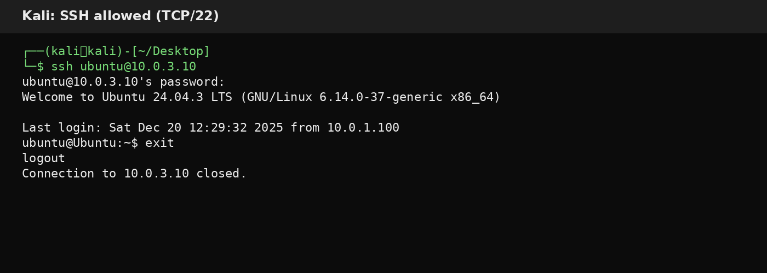
Figure 2. Kali successfully SSHes into Ubuntu in the DMZ (TCP/22 allowed).

6.2 Allowed traffic: HTTP lab service (LAN → DMZ, TCP 8000)
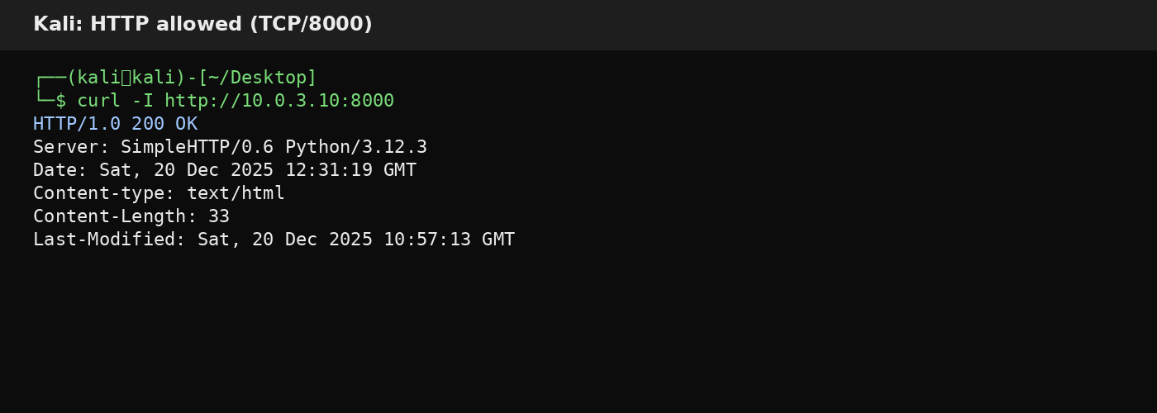
Figure 3. Kali receives HTTP 200 OK from Ubuntu's Python HTTP server (TCP/8000 allowed).

6.3 Blocked traffic: FTP port test (LAN → DMZ, TCP 21)
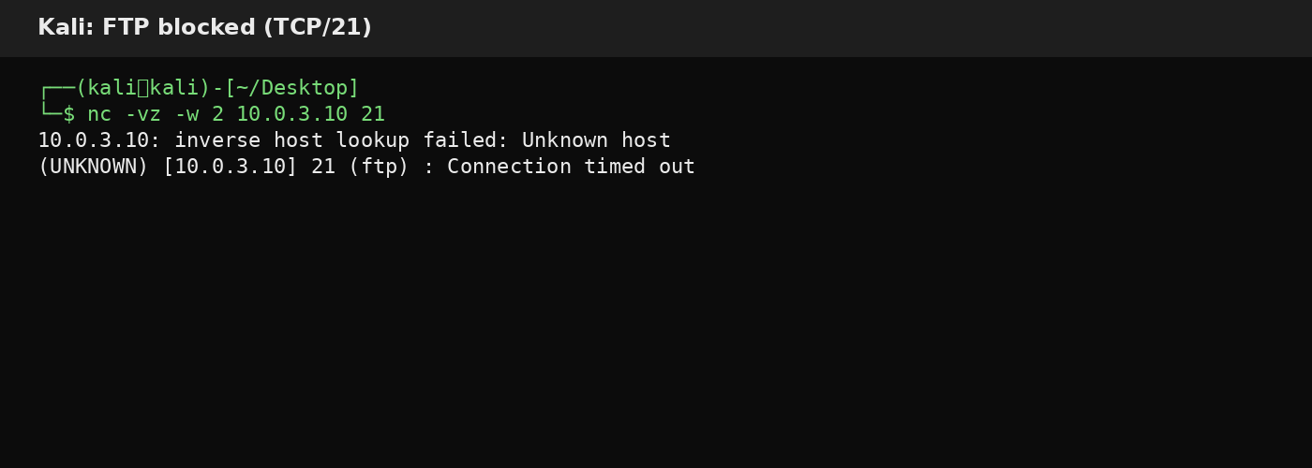
Figure 4. Kali test to TCP/21 times out (blocked by LAN→DMZ policy).

6.4 Blocked traffic: DMZ cannot initiate to LAN (ICMP)
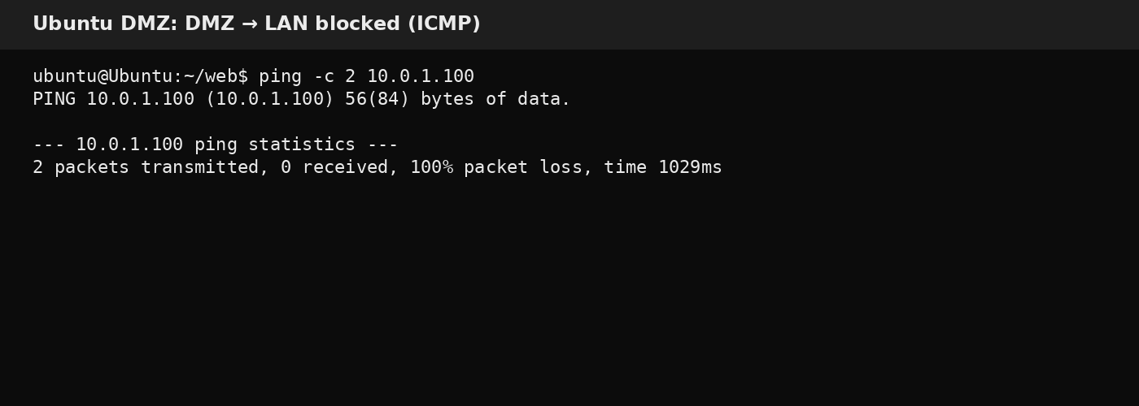
Figure 5. Ubuntu (DMZ) ping to Kali (LAN) fails (DMZ→LAN blocked).

6.5 DMZ static routing check
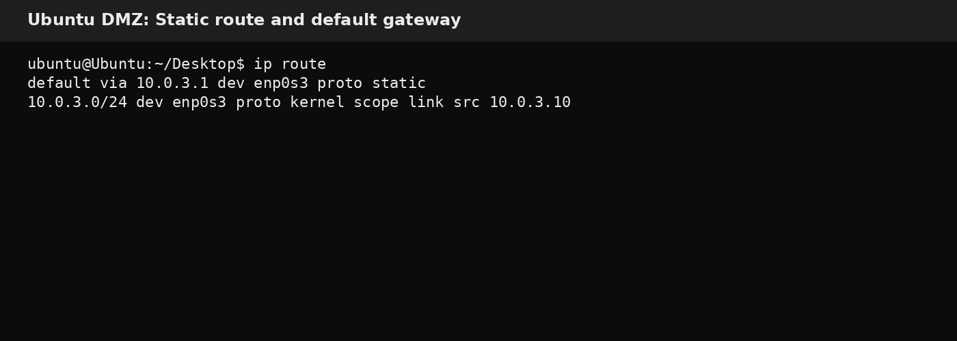
Figure 6. Ubuntu DMZ route table (default via 10.0.3.1).

7. Screenshot Checklist (to add)
- Status → Interfaces: WAN/LAN/OPT1 IP addresses visible.
- Firewall → Rules → LAN: allow 22, allow 8000, block to 10.0.3.0/24.
- Firewall → Rules → OPT1: block DMZ → LAN rule (or default deny).
- Status → System Logs → Firewall (optional): blocked entries while running the tests.

8. Conclusion
The lab successfully demonstrates network segmentation using pfSense. Only explicitly allowed services (SSH and HTTP lab port) are reachable from the LAN to the DMZ server, while the DMZ is prevented from initiating connections into the LAN. This matches a standard secure DMZ design.

